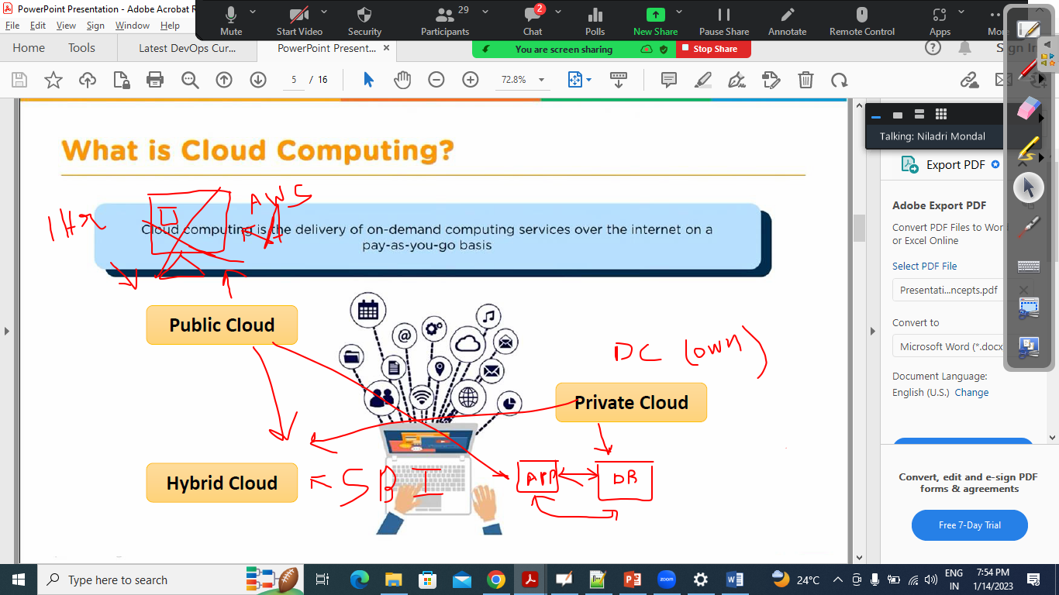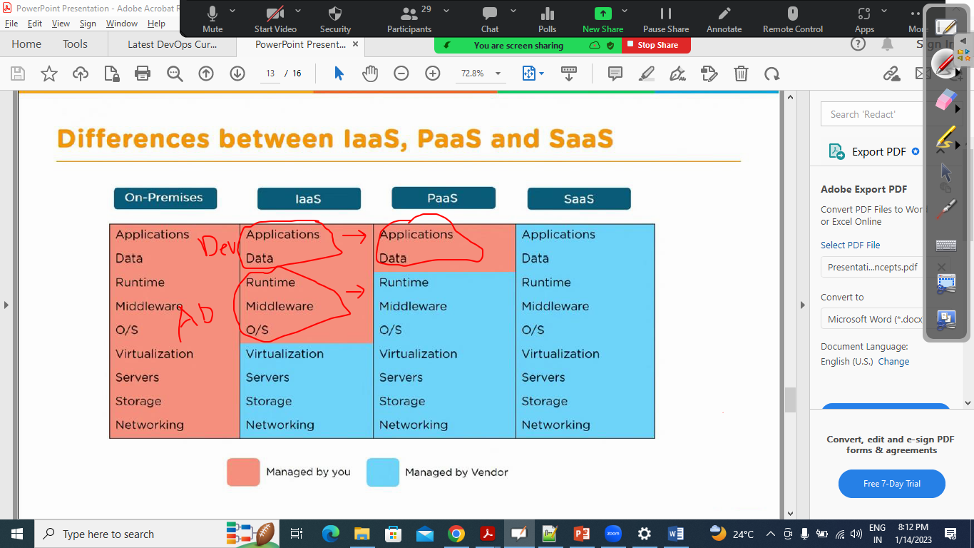

Aws Instance Type:

<https://aws.amazon.com/ec2/instance-types/?trk=32f4fbd0-ffda-4695-a60c-8857fab7d0dd&sc_channel=ps&s_kwcid=AL!4422!3!536392685920!e!!g!!aws%20instance%20types&ef_id=CjwKCAiAwomeBhBWEiwAM43YIDFW3KsuvF2wyfg-eya9Nq4MwsKwGkEl5sMxy4pc7uw2q9KksCkVjRoCQgwQAvD_BwE:G:s&s_kwcid=AL!4422!3!536392685920!e!!g!!aws%20instance%20types>

Setting up windows EC2 VM

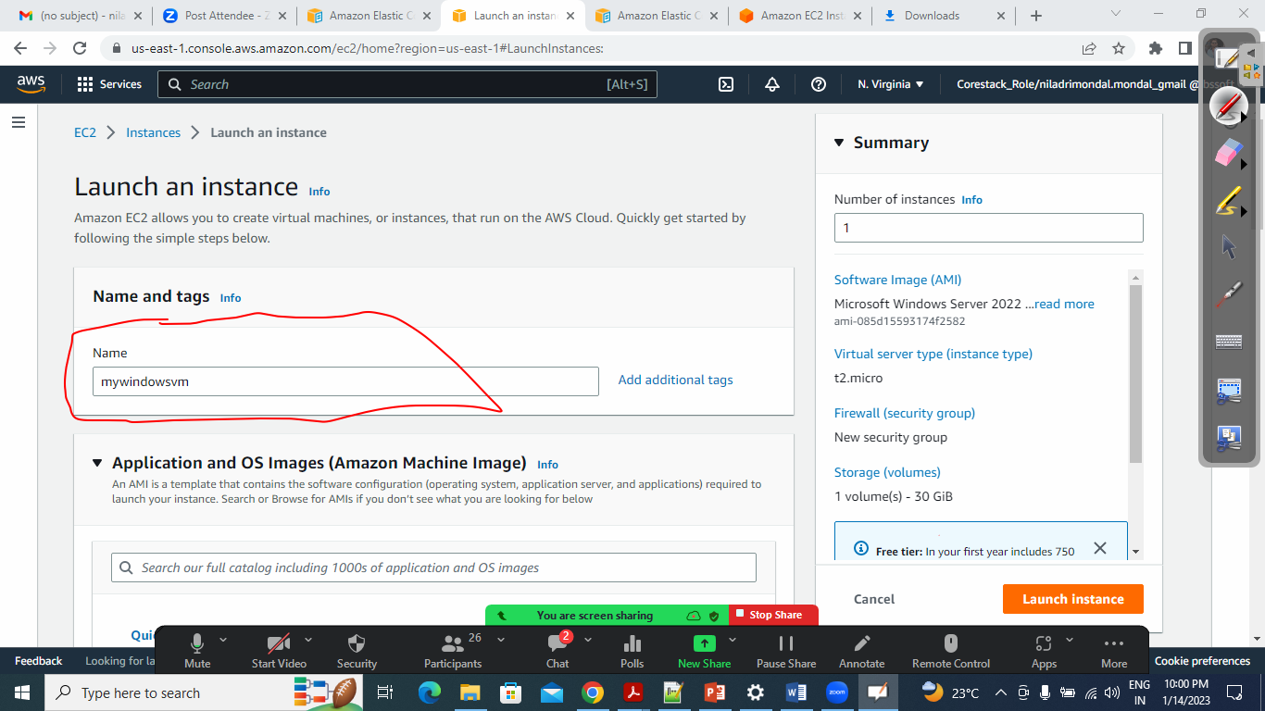

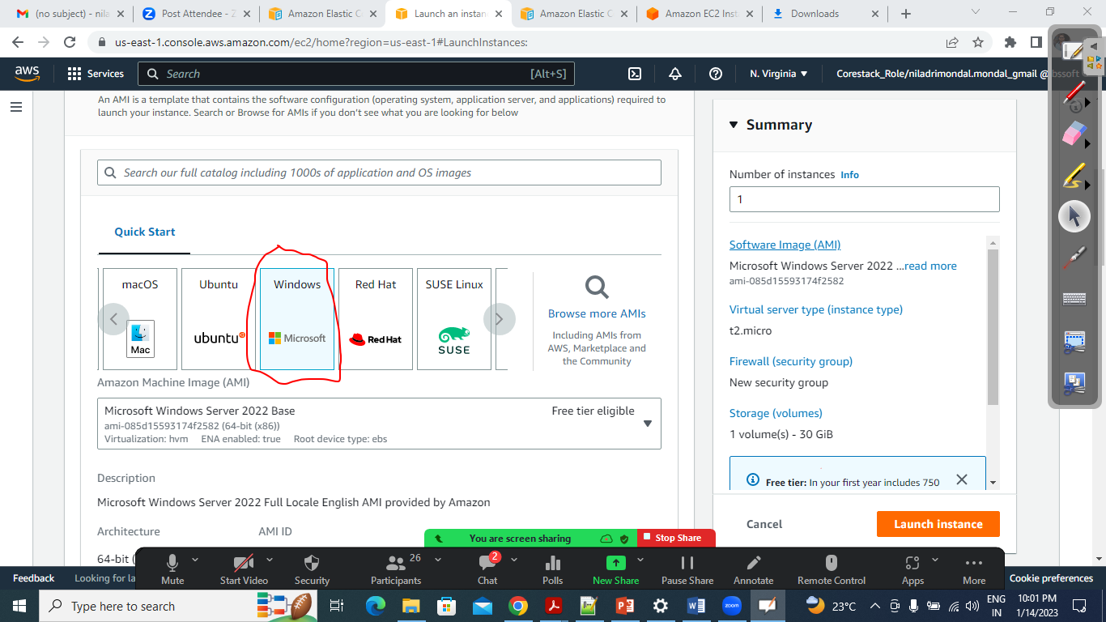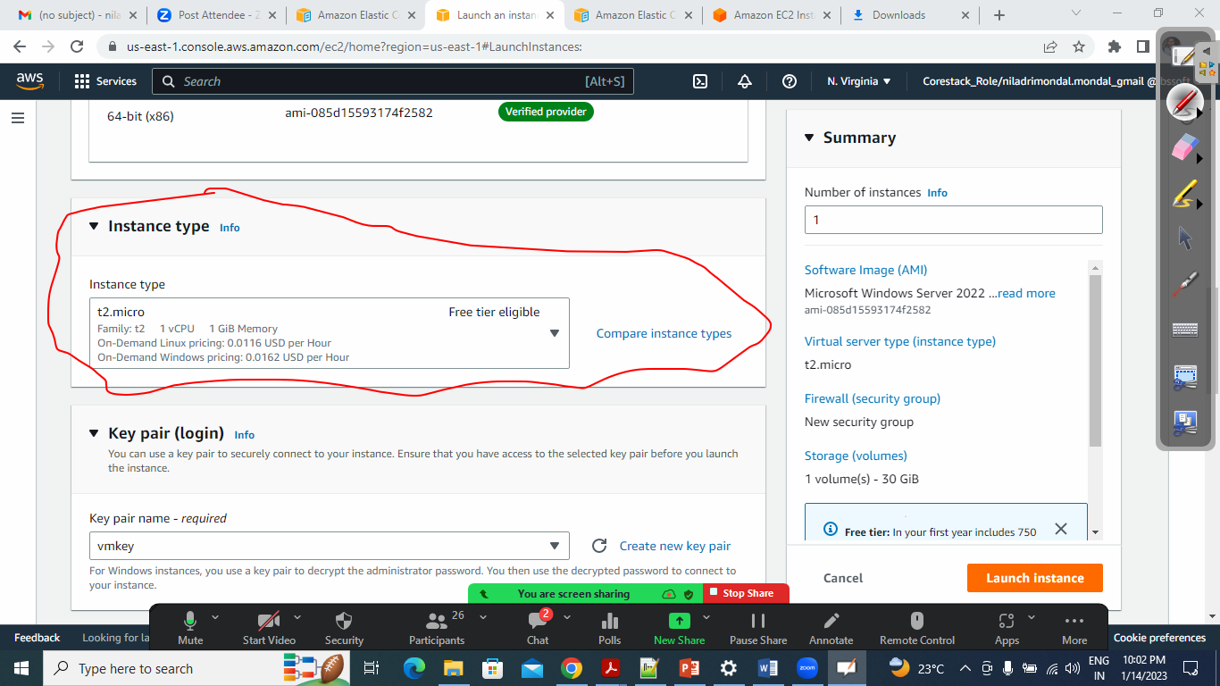

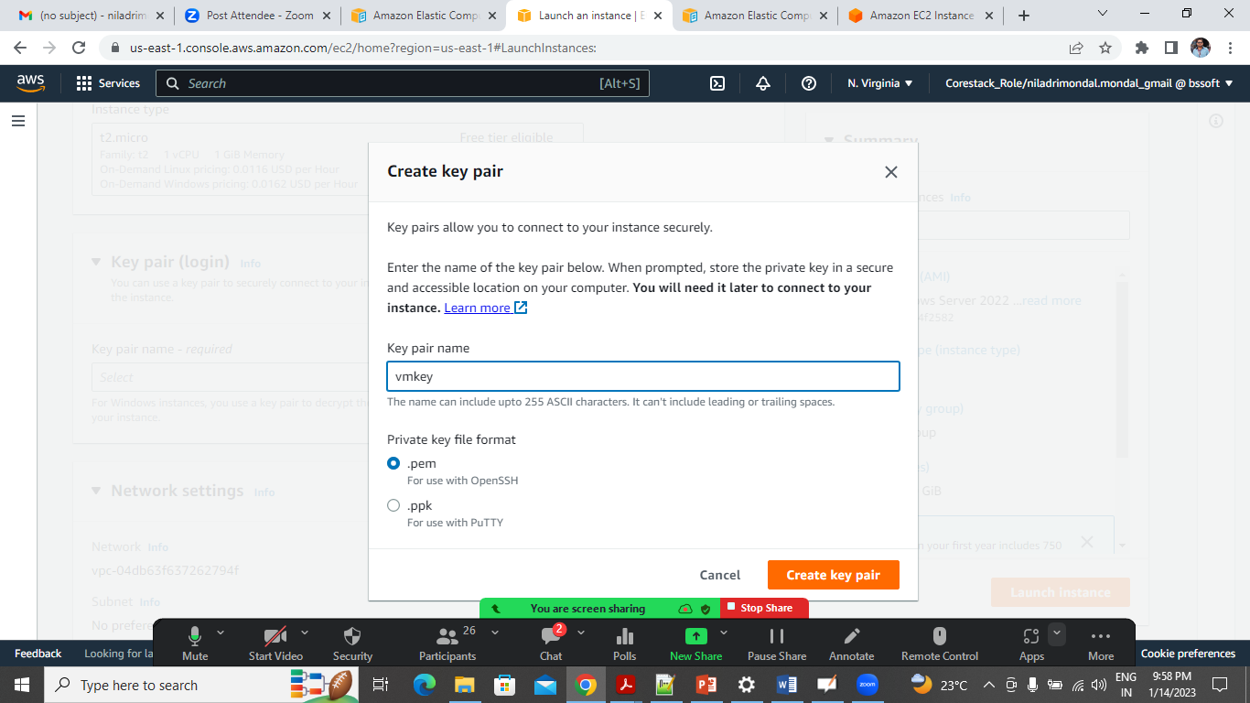

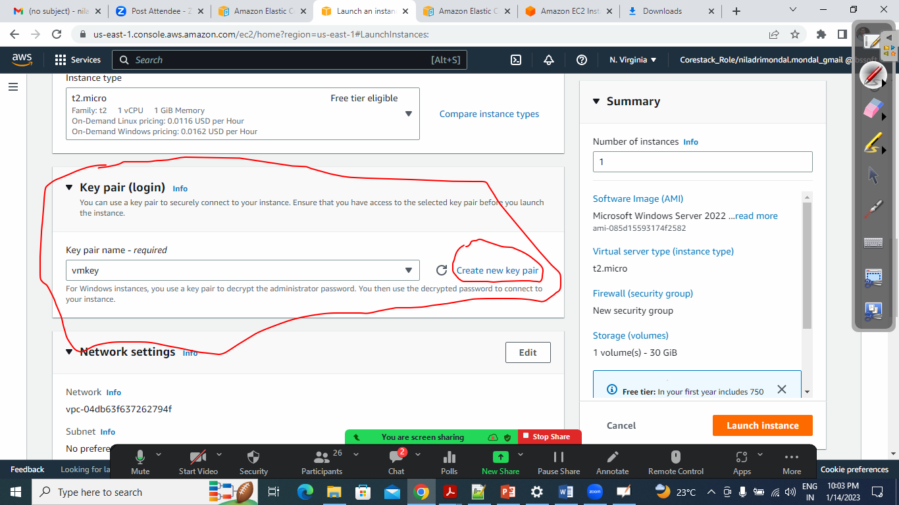

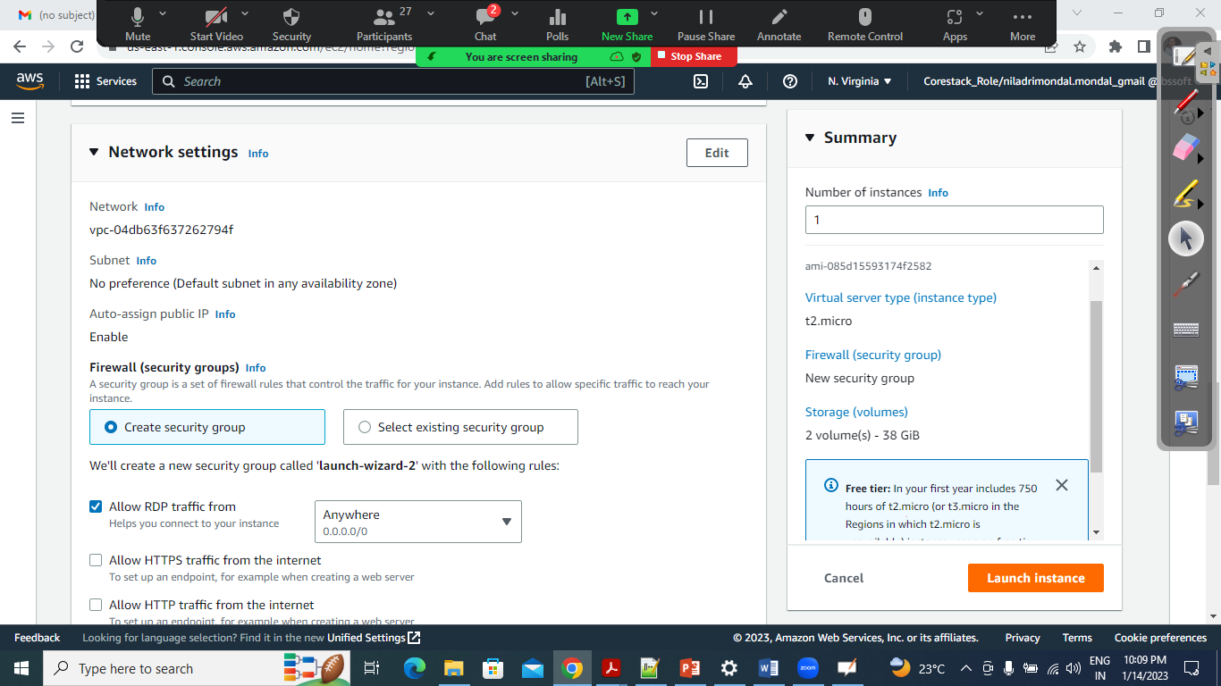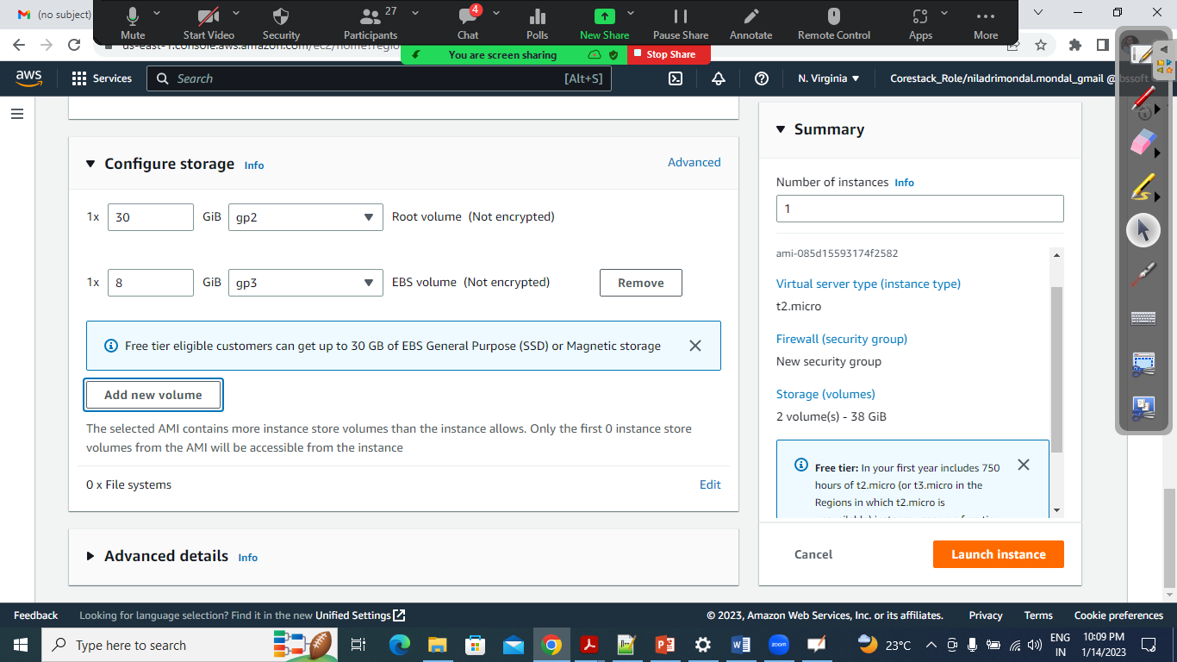

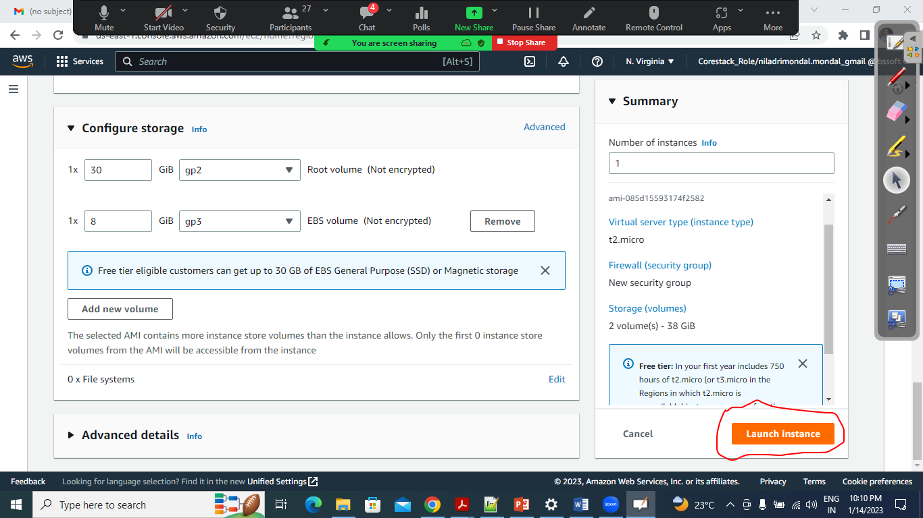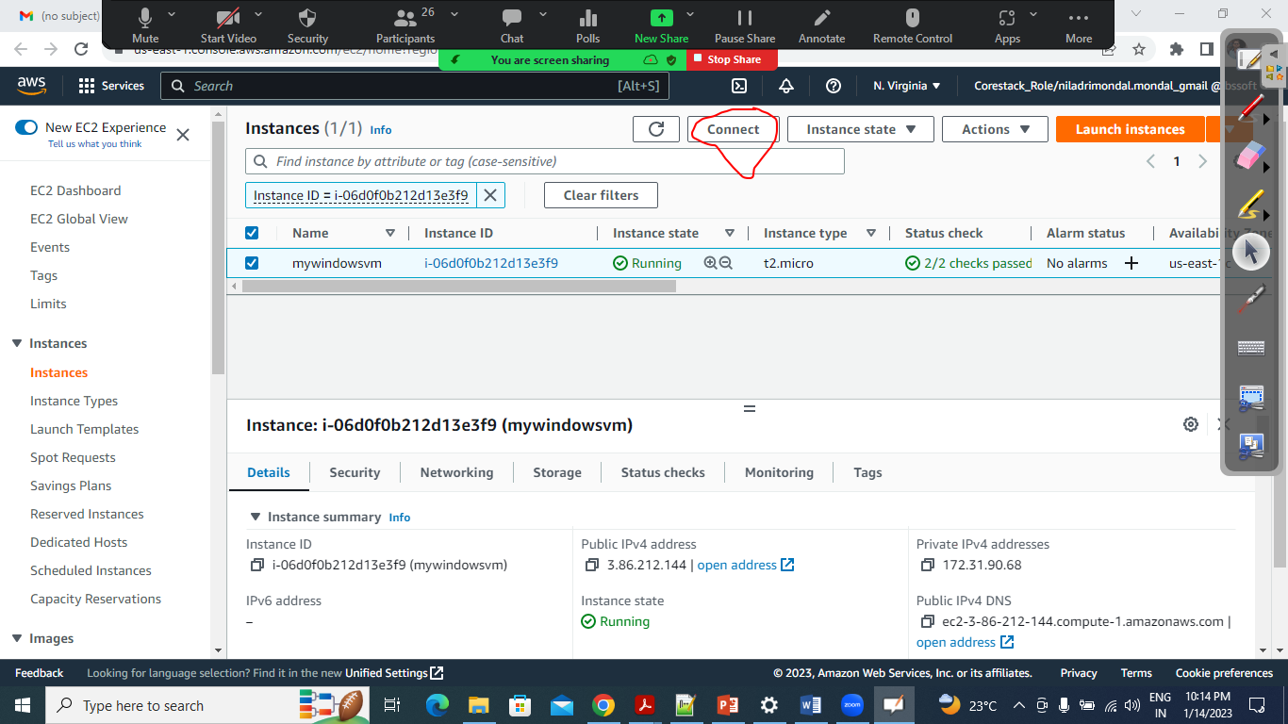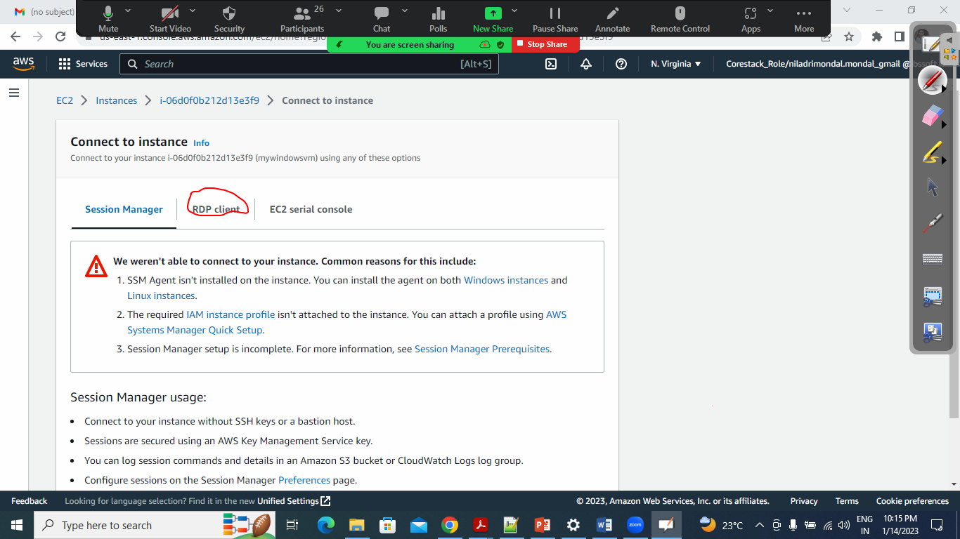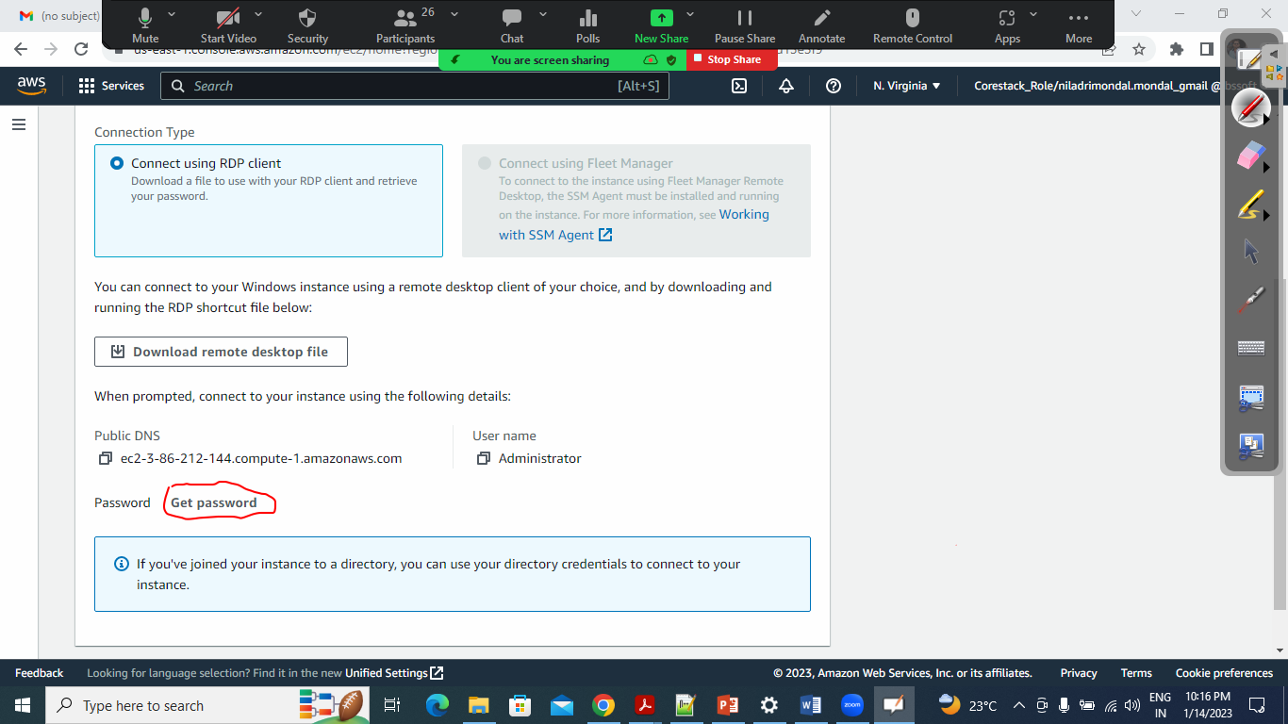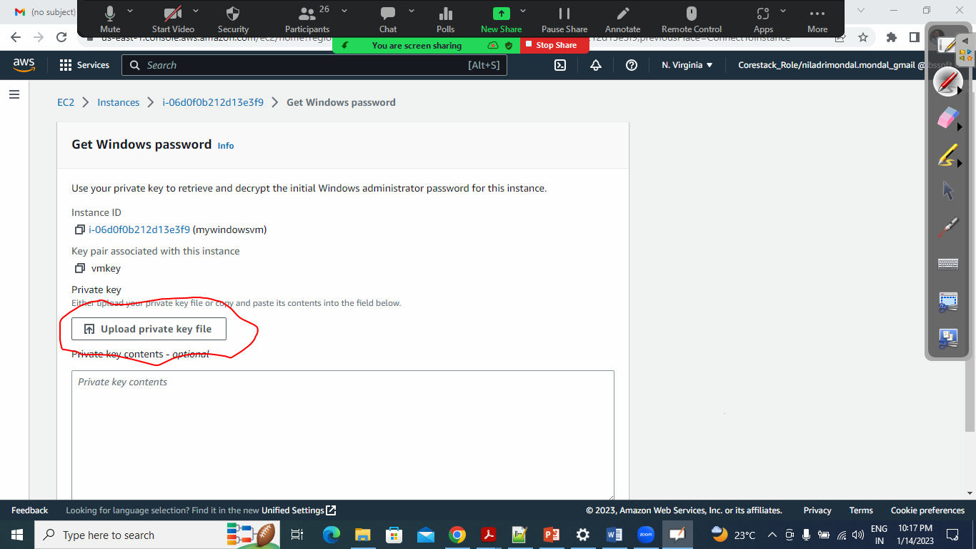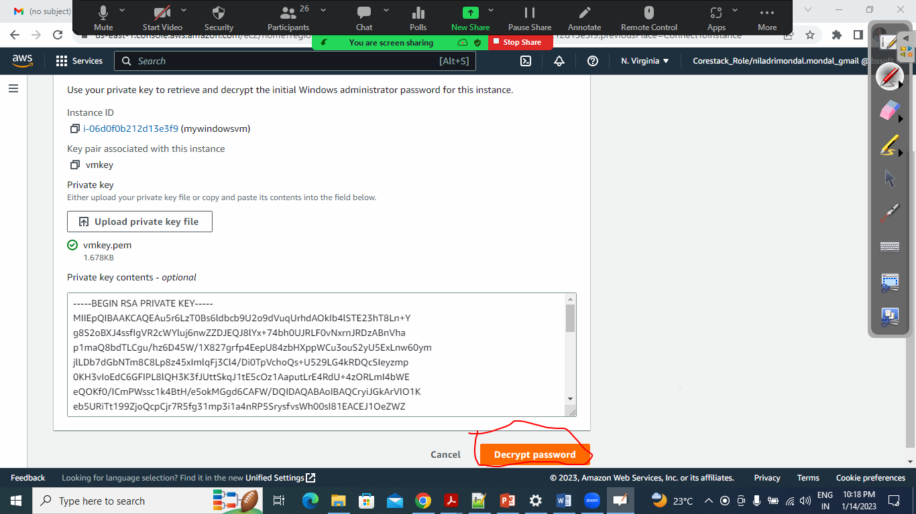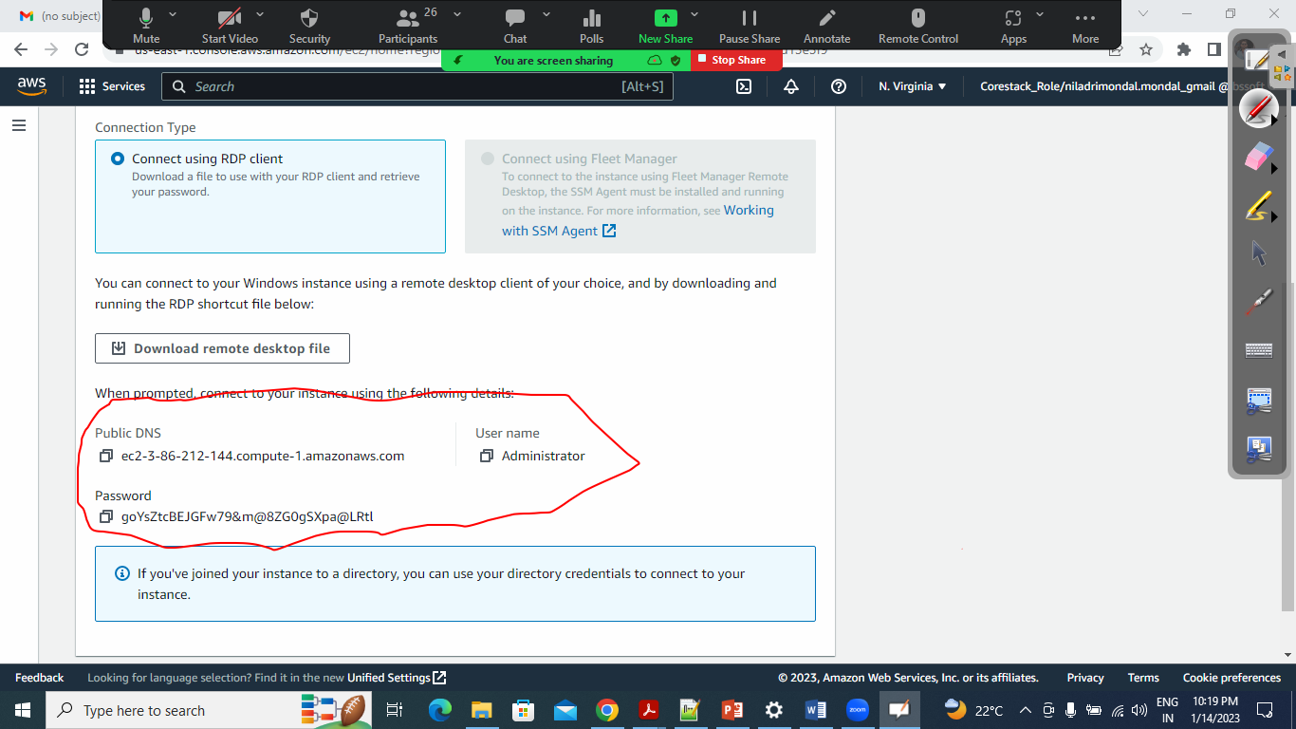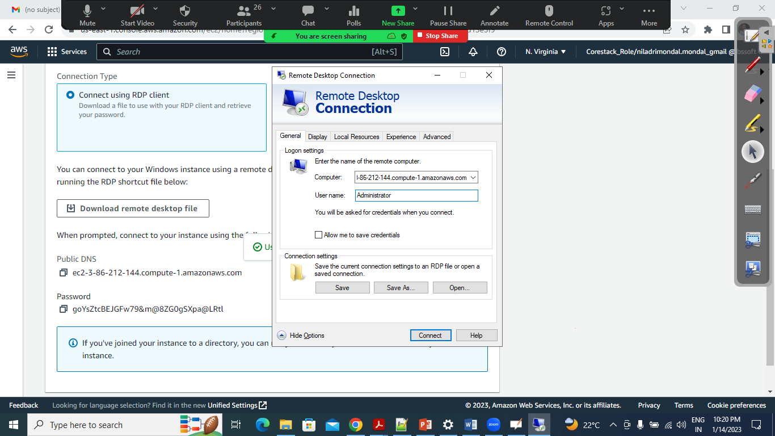

+++++++++++++++++++++++++++++++++++++++++++++++++++++++++++++++++++++++

Launch an Ubuntu Instance:

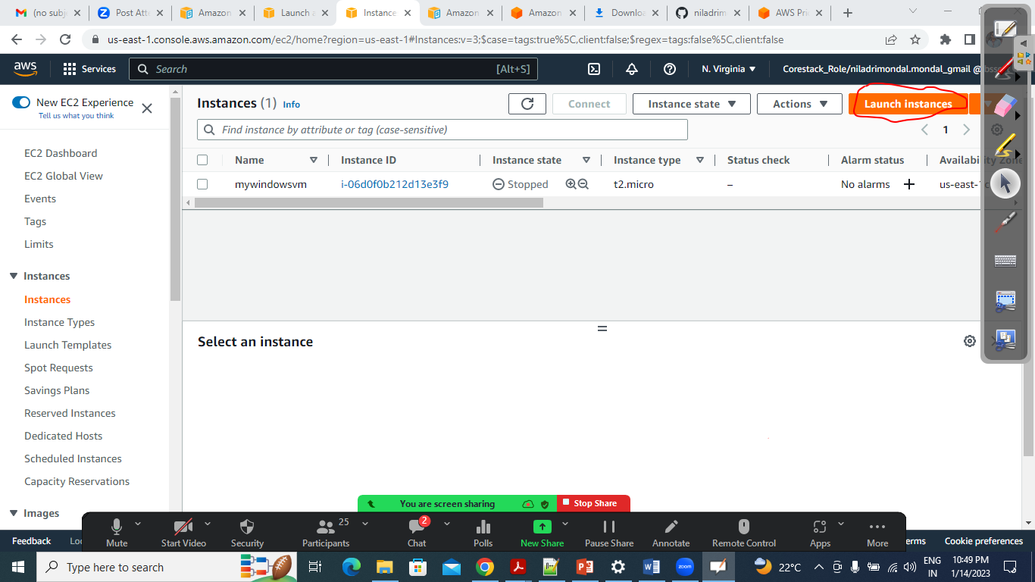

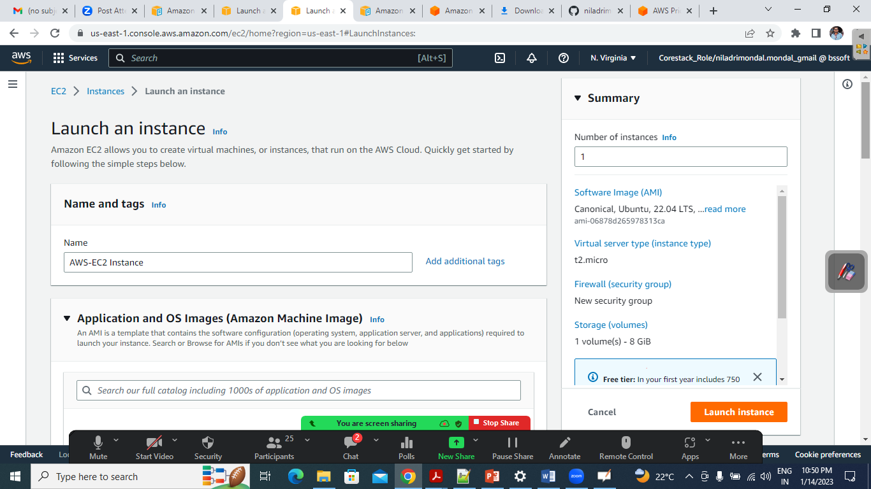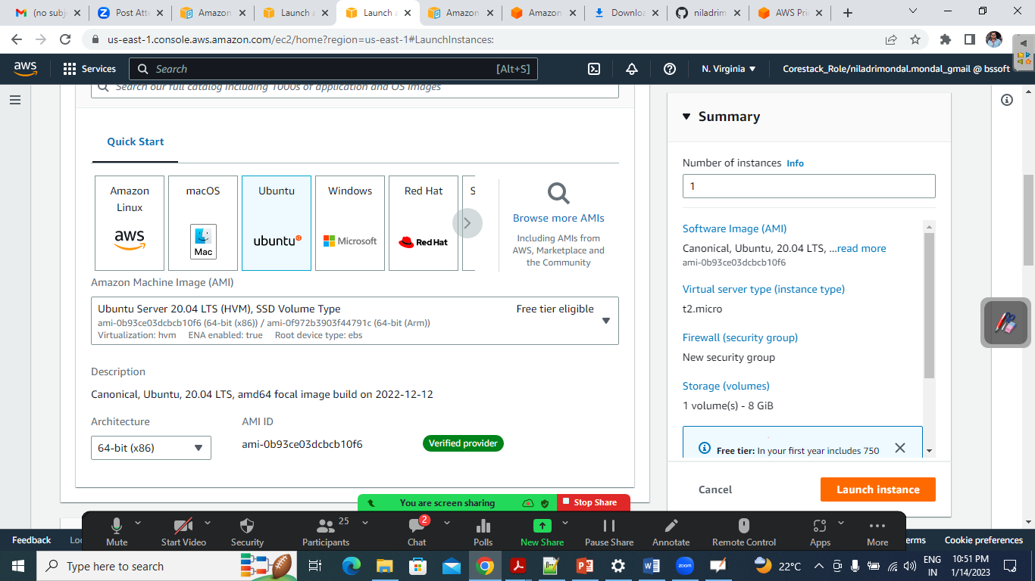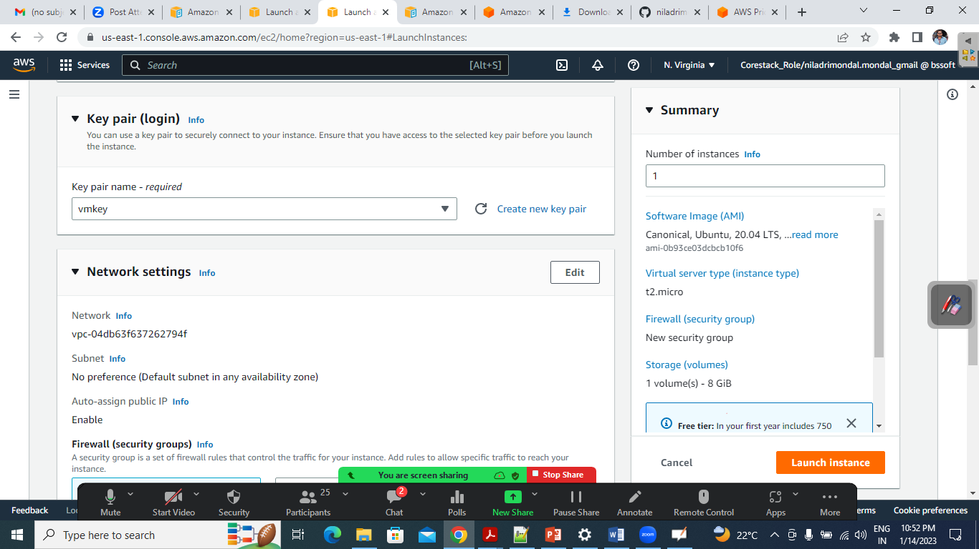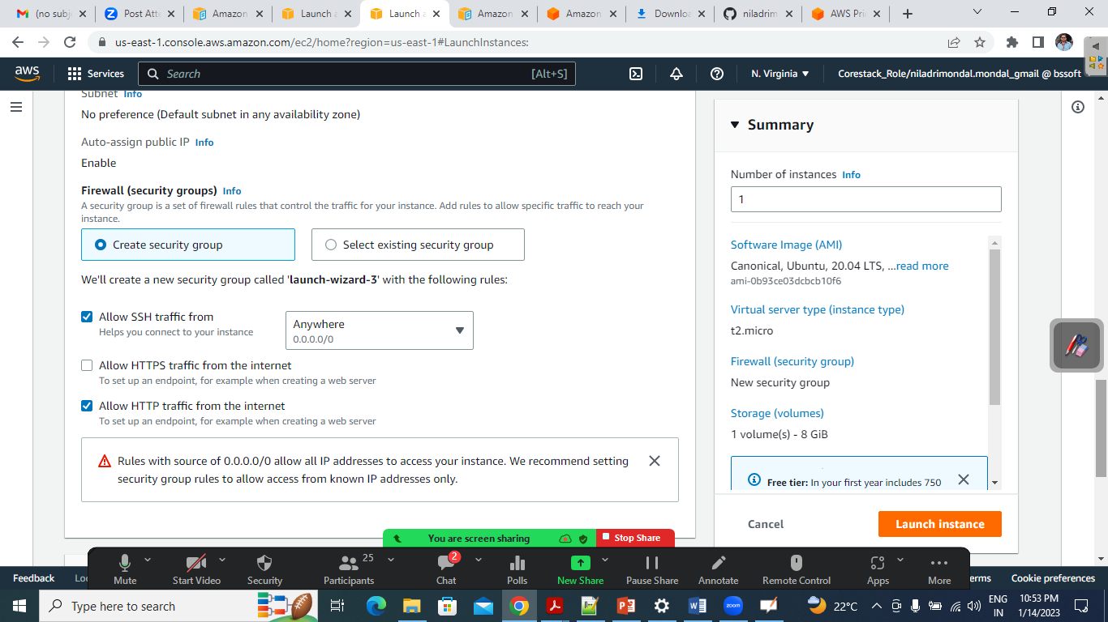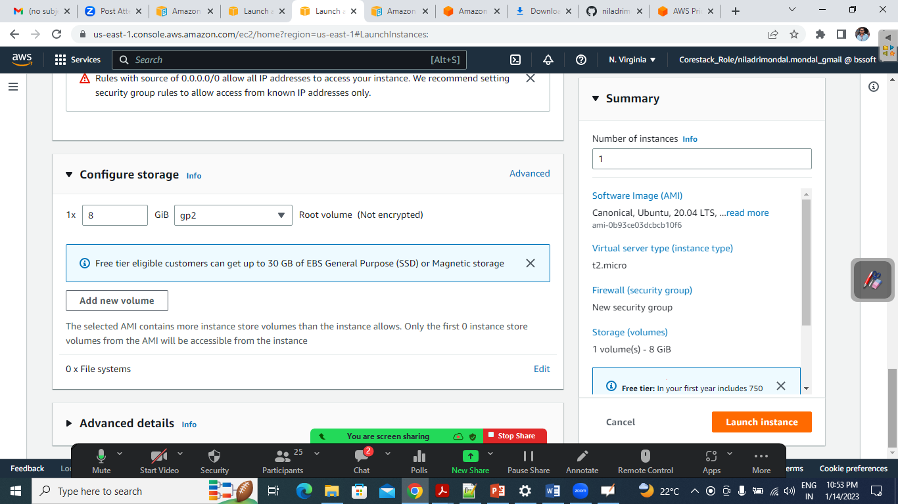

+++++++++++++++++++++++++

https://docs.aws.amazon.com/pdfs/AWSEC2/latest/UserGuide/ec2-ug.pdf